

Job Application Package Assignment Guidelines

Overview
A well-written, professional resume and a persuasive cover letter are your essential marketing tools for a successful job hunt. This activity will help you to create a professional resume that showcases the key qualifications employers are looking for when hiring students and recent graduates - your education, program- related skills, as well as your transferable skills and achievements. You will also practice composing a cover letter that will complement your resume, tailored to a sample job posting.

Process
Use the following steps as a guide to completing the Job Application Package Assignment.

- Complete the learning materials related to the Resume and Cover Letter Development topics in GEP1001-
Cooperative Education and Job Readiness.
- Prepare a resume following the recommended resume format and customize it to a sample job posting.
- Compose a cover letter to accompany your resume tailored to a sample job posting. Use the provided cover letter format as a guide when writing your cover letter.
- Log into your college Vmock account to assess your resume. Use the Vmock Resume Review Activity guidelines for instructions.
- Upload your resume, Vmock resume score screenshot and your cover letter to GEP1001 for review by the assignment deadline. (A sample screenshot is provided on page 3.)
- Your resume will be reviewed by a Co-op Student Advisor within two weeks of the assignment submission, and you will receive personalized feedback for improvement.

Evaluation
- Job Application Package Assignment is one of the essential co-op readiness activities. Both your resume and cover letter must be submitted for review and your resume must be assessed as Meets Co-op and Career Standards in order to gain access to co-op jobs in HireAC!
- Your resume will be assessed using the criteria listed in the Resume Checklist, which can be found on page 2 of this document. Please also review the resume assessment outcome details below.

Your Resume | Outcome
Resume achieves the essential criteria listed in the Resume Checklist:  - Resume Sections (Essential)  - Writing Style: Is the resume free of spelling and grammar errors? (Essential) | Resume meets the Co-op and Career standards. Access to Co-op jobs in HireAC granted after completion of all required activities in GEP1001.  Next steps: Make the appropriate changes to your resume following the feedback offered in GEP1001.
Resume does not demonstrate completion of the Resume Checklist:  - Resume Sections (Essential) and/or  - Writing Style: Is the resume free of spelling and grammar errors? (Essential) | Resume does not meet the Co-op and Career resume standards. Access to Co-op jobs in HireAC is not granted  Action required: Revise your resume following the feedback offered and re-submit it for review in GEP1001.

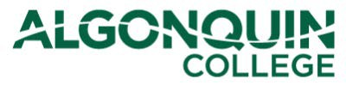

VMock SMART Career Platform
Algonquin College Resume Review Activity

The purpose of this resume review activity is for learners to improve their resumes based on personalized feedback and community best practices. VMock will assess how well you have marketed your core competencies and assist you in showcasing the skills you’ve gained though your academics and experiences.

GETTING STARTED

Save your current resume in a PDF format. You are recommended to do this by following these simple steps:
- Open your completed resume in Microsoft Word.
- Click on File and then "Save As".
- When the "Save As" window opens, in the drop-down menu next to
"Save as type: ", select "PDF (*.pdf)", "Best for printing" and click on "Save".

Go to www.vmock.com/algonquincollege and Login.

You will be given an option to “Upload” or “Create” a resume. If uploading, make sure your resume is in PDF format (refer to Step1) for the assessment.

Click on “View Detailed Feedback” and explore the feedback provided by the system on various parameters- Impact, Presentation and Competencies.

Review the personalized, targeted feedback provided by the system, and incorporate the suggestions to revise your resume.
- You will also have an option to edit your resume using the “SMART Edit” feature.

After incorporating the suggestions, “Re-score” your resume. You will be given a new score, which should be higher. Aim for a score of 50 or above, and for the 3 core modules (Impact, Presentation, Competencies) to be in the orange 'On Track!' zone.

Click on the “Help” button in the bottom right-hand corner if you need further assistance, there is a “Quick Guide” which will show you how to use the different features of the platform as well as a FAQ document. Feel free to also email Customer Support if you are experiencing technical or system-related issues.
**Each student has 10 resume uploads per academic year, please make as many changes as possible to your resume document before re-scoring it.

VMock Conﬁdential Document Proprietary and Conﬁdential. Please do not distribute.

Vmock Resume Review Activity – Screenshot

Follow the Vmock Resume Review Activity guidelines to review, score and improve your resume.
- Take a screenshot of your Resume Score Summary page and submit it as part of your Job Application Package assignment before the assigned deadline.
- Vmock Resume Score Summary screenshot should include the following information:
  - Your initials at the top right hand corner of the page.
  - The overall score for your resume. Aim for a score of 50 or above.
  - Your score for the three core modules, Impact, Presentation, and Competencies, assessed by Vmock. Aim for the score for each of the three modules to be in the orange 'On Track!' zone.
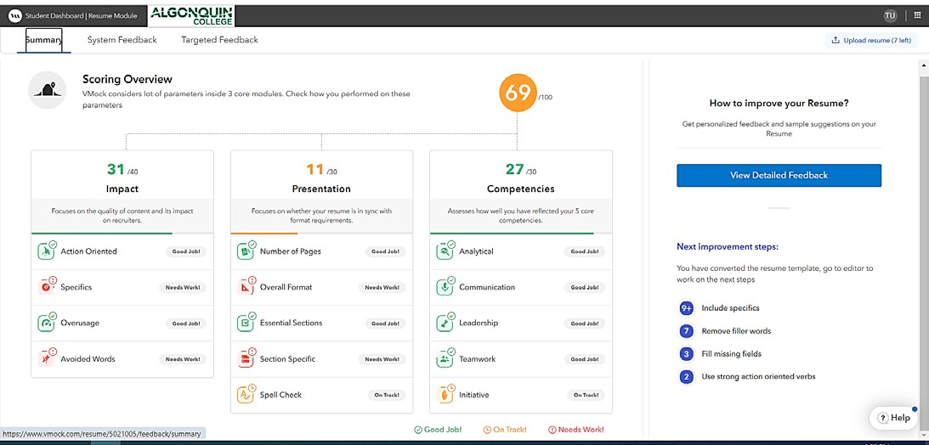

Resume Checklist
Student Name: Program:

1. Resume Sections (Essential) | YES | NO | Comments
Resume Header
- Is Algonquin Student Email (Algonquin Live) included?
Education
- Is the Education section listed with correct full name of program with accurate dates? (Month/year of start date – Present or anticipated graduation date)
- Is it hyperlinked to the program website?
- If other educational credentials are included, is the current or most the most recent credential listed first (i.e. using reverse-chronological order)?
Program-Related Skills or Summary of Qualifications
- Is a Skills section included on the first page of a resume?
- Does it list 5-10 industry-specific skills learned within the program of study?
- Does the Skills section lists 4-5 employability/transferable skills (not personal attributes)
Work-Experience
- Is work experience listed in a reverse chronological order (current or most recent job first)?
- Do job descriptions include 4-7 bullets that describe tasks, transferable skills used and results achieved? (Action Verb + Task/Skill + Outcome)
- If paid work experience is not included, is the Academic Projects or the Volunteer Experience projects section included?
2. Writing Style (Essential) | YES | NO | Comments
- Are effective action verbs used for work/volunteer experience descriptions?
- Is the resume free of spelling and grammar errors?
- Are personal pronouns (I, me, my) not included in the resume?
- Are the verbs in the resume in proper verb tenses (present tense for current duties and past tense for former duties)?
3. Appearance (Essential) | YES | NO | Comments
- Is the font easy to read? (11-12 points max.)
- Is there consistent formatting for headings, dates, titles, employers, and bullet lists?
- Are resume margins appropriate and equal length on all sides?
- Is the length of a resume appropriate (1-2 pages with an additional page for references if needed)?
4. Resume Sections (Optional) | YES | NO | Comments
Academic Projects or Projects
- Are related projects (academic or personal) listed with a project title, course name, and a brief description of tasks/results?
Related Experience
- Is the Related Experience section presented on the first page, after the Skills section
- Do job descriptions include 4-7 bullets that describe tasks, transferable skills used and results achieved? (Action Verb + Task/Skill + Outcome)
Volunteer /Extra-curricular activities
- Are the activities in this section listed in a reverse chronological order?
- Do volunteer roles listed include a title, organization name and a brief description of student’s duties, skills or achievements?
Certifications/Licenses/Trainings
- Are relevant credentials listed with a title, organization name and dates?

